
UT/BSQP/1223/B 02-NOV-2023
UNIT TEST (2023-24)
Subject: Business Studies  Grade: 12 |  |  | Max. Marks:50  Time: 2 Hours 30 Mts
Name: |  |  |  |  | Section: | Roll No:
General Instructions:
- This question paper contains 20 questions.
- Marks are indicated against each question.
- Answer should be brief and to the point.
- Answers to the questions carrying 3 marks may be from 50 to 75 words.
- Answers to the questions carrying 4 marks may be about 150 words.
- Answers to the questions carrying 6 marks may be about 200 words.
- Attempt all parts of the questions together.
1. | The object of the marketing department of Sundaram Kids Wear limited is to increase their sales by 10% by offering discounts. But the finance department may not approve of such discounts as it means loss of revenue. These kinds of conflict arise in organization because each department is performing activities in isolation from others and barriers between departments are becoming more rigid identify the point of importance of coordination to which this case is referred. |  |  |  |  |  | 1
 | a. | Growth in size |  | b. | Functional differentiation
 | c. | Specialization |  | d. | None of this
2. | According to the technique of scientific management differential piecewise system how much more will a worker making 60 units are as compared to a worker making 49 units? If the standard output per day is 50 units and those who make standard output are more than standard gets rupees 75 per unit and those below gets rupees 65 per unit. |  |  |  |  |  | 1
 | a. | Rs. 4,500 |  | b. | Rs, 3185
 | c. | Rs. 1315 |  | d. | Rs. 3,250
3. | Assertion: Planning will be a futile exercise if it is not acted upon or implemented.  Reason: Planning is time consuming and sometimes not much time is left for its implementation. |  |  |  |  |  | 1
 | a. | Both assertion and reason are true, and reason is the correct explanation of assertion. |  | b. | Both assertion and reason are true but reason is not the correct explanation of assertion.
 | c. | Assertion is true but reason is false. |  | d. | Assertion is false but reason is true.
4. | Kiran Industries is a company dealing in office furniture. The company chose to diversify its  operations to improve its growth potential and increase market share. As the project was  important, many alternatives were generated for the purpose and were thoroughly discussed amongst the members of the organization. After evaluating the various alternatives, Sukhvinder,  the Managing Director of the company, decided that they should add „Home Interiors and Furnishings‟ as a new line of business activity.  (a)Name the framework, which the diversified organization should adopt, to enable it to cope with the emerging complexity? |  |  |  |  |  | 1
 | a. | Functional Structure |  | b. | Divisional Structure
 | c. | Formal Organization |  | d. | Informal Organization
5. | Match the various ‘Selection Test’ in Column-I with their respective statements in Column-II |  |  |  |  |  | 1
  A | Aptitude Test | (i) | it indicates a person's capacity to develop
  B | trade test | (ii) | it is used to measure the existing skills of the individual
  C | personality test | (iii) | is an indicator of a persons learning ability or the ability to make decisions and judgments
  D | intelligence test | (iv) | this is used to know the clues to a person's emotions
 | a. | A-(ii),B-(i),C-(iii),D-(iv) |  | b. | A-(i),B-(ii),C-(iv),D -(iii)
 | c. | A-(iii),B-(i),C-(ii),D-(iv) |  | d. | A-(iii),B-(ii),C-(i),D-(iv)
6. | Unlike professions such as medicine or law which require a practicing doctor or lawyer to possess valid degrees now here in the world it is mandatory for a manager to possess any such specific degree. But professional knowledge and training is considered to be a desirable qualification since there is a greater demand for those who possess degrees or diplomas from reputed institutions.  Identify the features of profession to which the above case is related. |  |  |  |  |  | 1
 | a. | Well defined body of knowledge |  | b. | Restricted entry
 | c. | Professional association |  | d. | Service motif
7. | 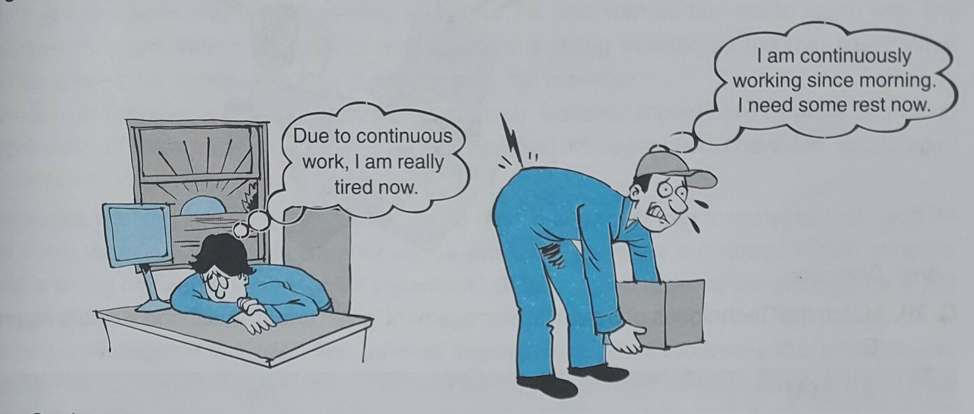  The following pictorial presentation highlights the need to conduct one of the techniques of scientific management. Identify the technique |  |  |  |  |  | 1
 | a. | Method Study |  | b. | Fatigue Study
 | c. | Time Study |  | d. | Motion Study
8. | According to a survey, these days young children have more power in purchasing decisions than ever before. The parents seek their kids' opinions about all kinds of once-adult decisions, including where to go for dinner, what kind of car to buy, even what to wear,". Therefore, the retailers are adapting to this by enhancing their kids' sections. If the children want to shop in the store for their clothes, then there's a greater chance that the parent will also see something they want to buy as well.  Identify the type of plan being described in the above lines. |  |  |  |  |  | 1
 | a. | Program |  | b. | Method
 | c. | Strategy |  | d. | Rule
9. | Ms. Bindu works as production manager in a company. She divided the work among her subordinates in accordance with their interest in ability. Not only this, she even gave them all the authorities to take decisions relating to their work. At the end of the first month of the year, it was found that Mr. Raj had not achieved his target. He was lagging far behind his target. Ms Bindu asked him to give the reason within two days why his performance was low. With which concept of management, the conversation between miss Bindu and miss Raj referred to in the above para is related? Identify it. |  |  |  |  |  | 1
 | a. | Authority |  | b. | Accountability
 | c. | Responsibility |  | d. | None of the above
10. | Identify the correct sequence of the steps involved in the selection process |  |  |  |  |  | 1
 | a. | Medical examination, Contract of employment, Reference and background checking, Selection decision, Job offer |  | b. | Reference and background checking, Selection decision, Contract of employment, Medical examination, Job offer
 | c. | Job offer, Reference and background checking, Selection decision, Medical examination, Contract of employment |  | d. | Reference and background checking, Selection decision, Medical examination, Job offer, Contract of employment
11. | Explain :  - Science not Rule of thumb’ as Principle of Management and  - ‘Motion Study’ and ‘Time Study’ as techniques of scientific management. |  |  |  |  |  | 3
12. | Hitesh is the Chief Executive Officer of 'Kids Garments Ltd.' Due to the festive season, Hitesh got an additional order of 10,000 garments which he had to supply within two days. Due to his goodwill in the market, he did not want to lose the order. So, he decided to achieve the target by operating on double shifts. He achieved the target and supplied the order within two days. But due to double shifts, his cost of production was higher than the regular production cost.  Identify and give the meaning of the two concepts of management discussed in the above para. |  |  |  |  |  | 3
13. | Under this training method, it is a joint program of training in which educational institutions and business firms cooperate. Identify the type of training. Also state any other three types of training. |  |  |  |  |  | 3
14. | Roasted Coffee Corporation is a coffeehouse chain operating in seven states of India. Through its effective organizational structure, it has grown despite pressure from competitors in the national market. The company has a Purchase and Production department, Supply chain management and logistics department, Brand management department and Sales department. This structure has facilitated operational efficiency, as employees became specialists within their own realm of expertise. They could be imparted specialized training as the focus was on a limited range of skills.  Identify the organizational structure of Roasted Coffee Corporation. Also, state the three advantages of this structure other than those discussed in the above paragraph. |  |  |  |  |  | 3
15. | Monika, ‘Rashmi and Garima are childhood. Friends. After completing their education, Monika joined a school. Rashmi joined a firm as Chartered Accountant and Garima as a General Manager ‘in a Multinational Company. After a long time in a reunion function of the school, they met each other. Rashmi. Said that they were all professionals now. Garima told Rashmi that she can say this about Monika and herself, but not about her since Manager is not considered as a full-fledged professional.  Why did Garima say that she was not a professional. State any three points in support of your answer. |  |  |  |  |  | 4
16 | Mr. Radha Krishan Kher is the Production Manager of "Krishna Milk Products Pvt. Ltd." He produces several milk products. Various alternatives are available for producing each product. It is the endeavor of Mr. Kher that best and cheap alternative be adopted in production. He has made a special arrangement in his department. According to it, a proper place will be earmarked for everything used in the production department. He has also directed the employees of the department that everything should be available at its decided place. There is a provision for awarding punishment to those who ignore this direction. All activities of Mr. Kher's department are closely related to each other. To maintain balance among them he makes special efforts so that there is no obstruction in production.  - Which technique of scientific management is being practiced by the company in the above paragraph?  - Quoting the lines, identify that function of the management which is called Essence of Management.  - Which principle of Henry Fayol is being followed by the company? |  |  |  |  |  | 4
17 | Mega Ltd. holds an Annual Management Programme every year in the month of March in which the top managerial personnel formulate plans for the next year by analyzing and predicting the future to meet future events effectively.  As they are responsible for providing direction to the organization, facts are thoroughly checked using scientific calculations. Detailed plans are prepared after discussion with professional experts. Preliminary investigations are also undertaken to find out the viability of the plan. Since it is an intellectual activity requiring intelligent imagination and sound judgement, so it is mainly done by the top management. Usually the rest of the members just implement the plans. Middle level managers are neither allowed to deviate from the plans nor are they permitted to act on their own. The top management ensures that the expenses incurred in formulating the plans justify the benefits derived from them.  State any two limitations and any two features of planning discussed above. |  |  |  |  |  | 4
18 | ‘It is a process by which the aptitude skills and abilities of employees to perform specific jobs are increased.’ Identify the process and any three of its benefits to the organization. |  |  |  |  |  | 4
19 | 'Shan Spices Ltd.' is the manufacturer of different food specific spices like Rajma Masala, Colley Masala, Aloo Paratha Masala etc. Mr. Raghav, the owner of the company, has created different departments for purchase, production, marketing, finance and human resource. There are thirty employees working in the organization. Planning is of paramount importance to the company as Mr. Raghav believes that effective planning leads to the achievement of organizational objectives. So, in order to make employees focus on objectives, he issued instructions that during working hours only official matters will be discussed. He made certain rules and code of conduct for the employees to follow, according to which employees are not allowed to visit and talk to the employees of other departments except for official work. He emphasized on work performance which resulted in smooth functioning of the organization.  i) Identify and state the type of organization mentioned in the above para.  ii) State one feature of the concept identified in part (i) as mentioned in the above para. |  |  |  |  |  | 6
20 | Ashish Mehra started a company ‘Micro’ for providing cyber security solutions to Businesses. Its objective is to prevent, detect and respond to cyber-attacks and protect critical data. He was a hardworking software engineer and an expert in cyber security. His reputation grew rapidly as he was not only a person of integrity but also did his work with utmost honesty and sincerity. The business started growing day by day. He was delighted when he was offered a big project by the Ministry of Defense. While working on the project, he found that the volume of work made it impractical for him to handle all the work by himself. He decided to expand the team. The company maintained a close liaison with a local engineering college. During a campus placement, Ishan and Vrinda were appointed to work for the new project.  He found the new employees capable, enthusiastic and trustworthy. Ashish Mehra was thus,  able to focus on objectives and with the help of Ishan and Vrinda, the project was completed  on time. Not only this Ashish Mehra was also able to extend his area of operations. On the  other hand Ishan and Vrinda also got opportunities to develop and exercise initiative.  (i) Identify and briefly explain the concept used by Aman Chadha in the above case which  helped him in focusing on objectives.  (ii) Also, briefly explain any four points of importance of the concept identified in (i) above |  |  |  |  |  | 6

***

